**Queries & outputs**

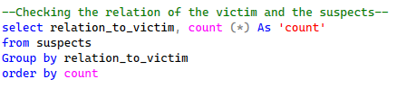

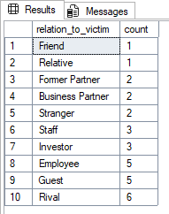



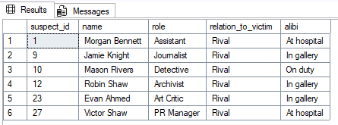

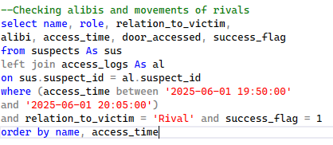

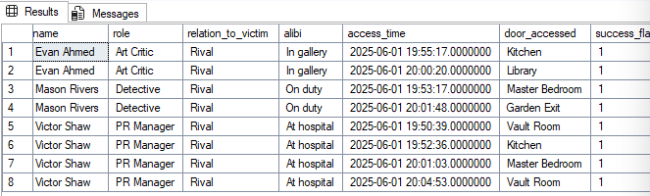

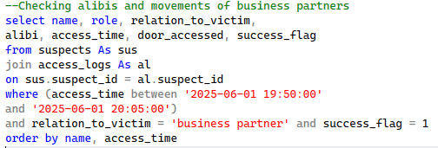

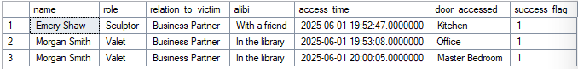

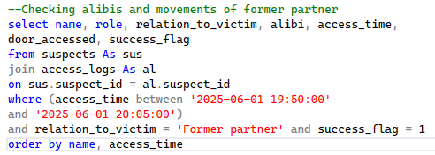

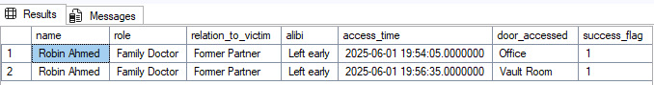

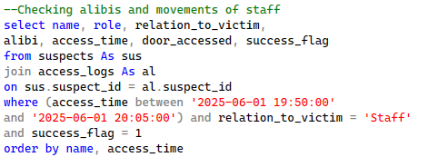



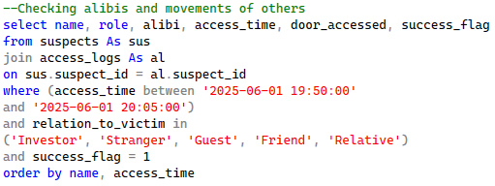

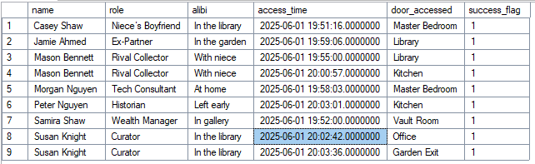

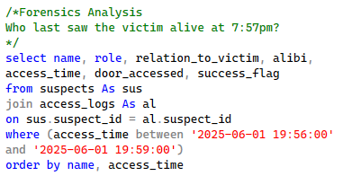

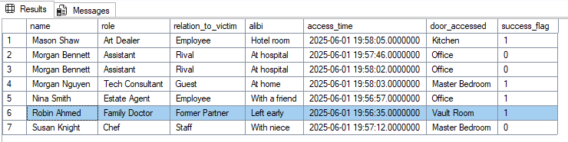

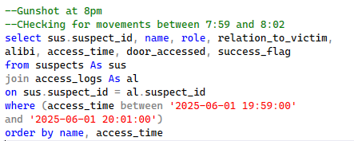

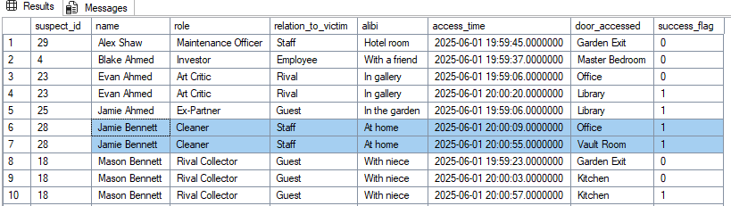

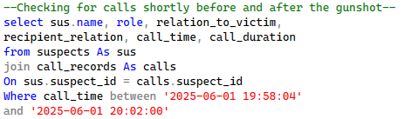

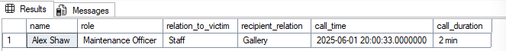

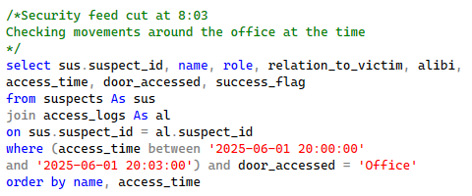

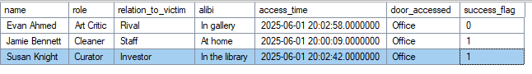

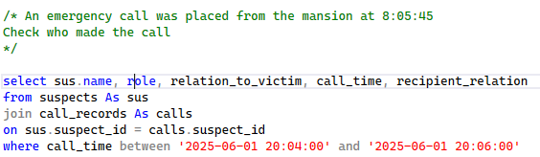



Missing call record

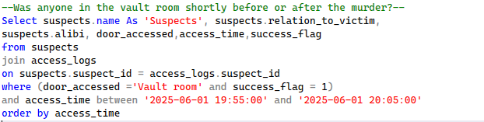

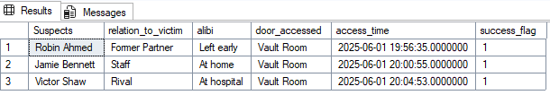

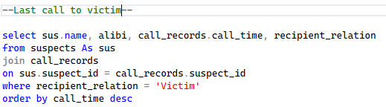

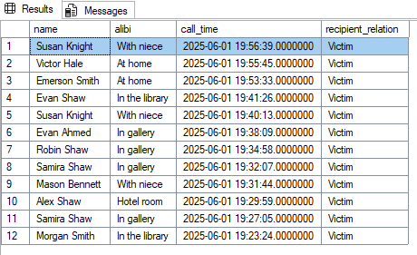

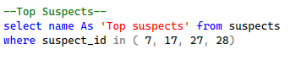

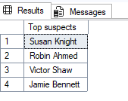

**Project Questions**

1. Who killed Roland Greene?? - Robin Ahmed
2. Who are the top three suspects and why?



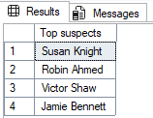Explanation is in the report.

1. Whose alibi does not match the forensic timeline?`Robin Ahmed, Jamie Bennett, Susan Knight, and Victor Shaw.
2. Was anyone in the vault room shortly before or after the murder?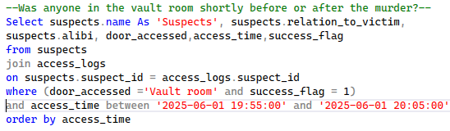

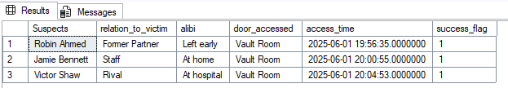

1. What does the call log reveal about the final call?





1. Are there any inconsistencies between access logs and alibi claims? All suspects’ movements overlapped with the critical window period.
2. What does the forensic timeline say about the time and manner of death? Time of death - 8 PM || Manner of death - Gunshot at close range.
3. Which suspect’s movement overlaps with the critical time window? Jamie Bennette - 8:00:09 & 8:00:55, Robin Ahmed - 7:56, Susan Knight - 8:03 (security cam cut off), Victor Shaw - 8:04:53
4. How do the data sources contradict or affirm one another? Answer in the investigation report.